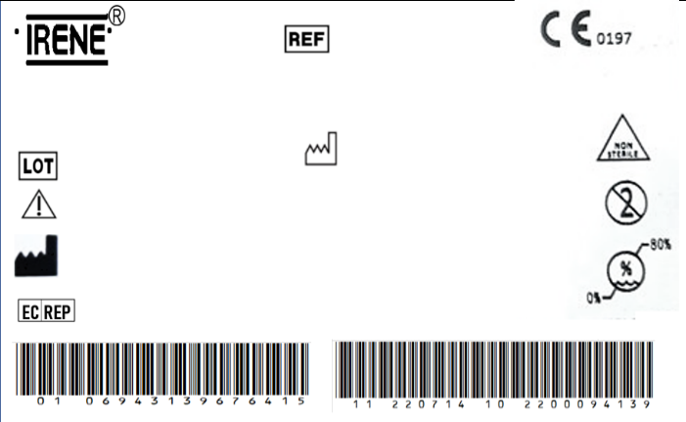

DIAMOND™ Cementless Acetabular Cup Screw

T35006535

2200108982

2022/08/02

REGISTRO SANITARIO

5877-DME-1118

IMPORTADO Y DISTRIBUIDO POR ORTOMAX- PINEDA CORAL JAIRO DARIO

The implante should be sterilized before surgery.

TianJin ZhengTian Medical Instrument Co., ltd.

No. 318, Jingyi Road

Airport Economic Zone 300308 TianJin P.R. China

Bricon GmbH

EisenBahnstrasse 100, 78573 Wurmlingen, Germany

2027/08/01